A000-Cyprus-Standing male figurine, Cypro-Archaic II, ca 600–480 BCE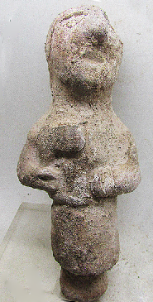 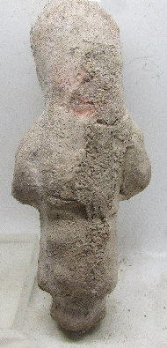

**Case no.:**

**Accession Number:**

**Formal Label:** Cyprus-Standing male figurine, Cypro-Archaic II, ca 600–480 BCE

**Display Description:**

This Cypriot terracotta is both wheel-made for the central volume of the body and hand-made for the distinguishing features. It represents a male holding the head of a halberd probably extolling the bronze weapons of this culture and presenting it as a gift.

**LC Classification:**

**Date or Time Horizon:**

**Geographical Area:**

**Map:**

**GPS coordinates:**

**Cultural Affiliation:**

**Media:**

**Dimensions:**

**Weight:**

**Condition:**

**Provenance:**

**Discussion:**

The Cesnola Collection has many such figurines

**References:**